**Class______ Student ID_____________ Name_________________ Instructor_____________**

**Date__________________ Pre-class Assignment Grade___________ Final Grade__________**

**Experiment: Collision and Targeting Experiment**

**I. Pre-Lab Preparation**

1. In this experiment, the collision process is as shown in the diagram. A target ball with mass m₂ is placed on a ball-bearing support pillar at a height y. A pendulum ball with mass m₁ is released from a height h₀, collides elastically with the target ball in the horizontal direction, and the target ball undergoes projectile motion with a horizontal displacement of x₀.

Under ideal conditions, neglecting air resistance and the friction between the ball-bearing support pillar and the target ball, analyze whether the momentum of the system consisting of the two balls is conserved during the collision.

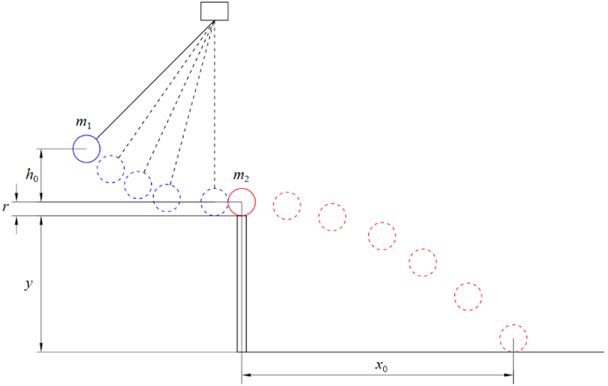

2. As shown in the diagram, derive the relationship between the pendulum ball's drop height **h₀** and the ball-bearing support pillar height **y**, the preset target position **x₀**, the pendulum ball mass **m₁**, the target ball mass **m₂**, and the target ball radius **r**, under ideal conditions (neglecting air resistance and the friction between the ball-bearing support pillar and the target ball, assuming the collision is elastic).In the subsequent experiment, the calculated value of **h₀** will be used to determine the release height of the pendulum ball.

**II. Original Data**

Table 1

|  |  |  |  |  |  |  |
| --- | --- | --- | --- | --- | --- | --- |
| Target Ball | Mass (g) | Diameter 2*r* (cm) | Preset Position $x_{0}$ (cm) | Ball-Bearing Support Pillar Height *y* (cm) | Height Difference *h*0 (cm) | Pendulum Ball Set Height *h*= *h*0+*r*+*y* (cm) |
| Steel Ball |  |  |  |  |  |  |
| Copper Ball |  |  |  |  |
| Aluminum Ball |  |  |  |  |

Table 1

|  |  |  |  |  |  |  |
| --- | --- | --- | --- | --- | --- | --- |
| Target Ball | Steel Ball | | Copper Ball | | Aluminum Ball | |
| Trial | Landing Position *x* (cm) | Pendulum Ball Position *h’* (cm) when $x=x_{0}$ ​ | Landing Position *x* (cm) | Pendulum Ball Position *h’* (cm) when $x=x_{0}$ ​ | Landing Position *x* (cm) | Pendulum Ball Position *h’* (cm) when $x=x_{0}$ ​ |
| 1 |  |  |  |  |  |  |
| 2 |  |  |  |  |  |
| 3 |  |  |  |  |  |
| 4 |  |  |  |  |  |
| 5 |  |  |  |  |  |
| 6 |  |  |  |  |  |
| 7 |  |  |  |  |  |
| 8 |  |  |  |  |  |
| 9 |  |  |  |  |  |
| 10 |  |  |  |  |  |

|  |  |
| --- | --- |
| **Teacher** | **Name** |
| **Signature** |  |

**III. Data Processing**

(Based on the measured data, calculate the theoretical height of the pendulum ball using the formula *h*= *h*0+*r*+*y*. Determine the average landing position $\overline{x}$ and, using the pendulum ball position *h’ w*hen the landing position equals the preset position *x*0, calculate the percentage of mechanical energy lost. The calculation process should be detailed and well-formatted.)

**IV. Experimental Conclusions and Phenomenon Analysis**

**V. Questions**

1. After the collision of two balls with the same mass, does the motion of the struck ball agree with the theoretical analysis? What does this phenomenon indicate?
2. If the target ball is not placed, can the pendulum ball reach its original height when swinging back? What does this imply?
3. In this experiment, what different effects would occur if the balls were made of paraffin wax or cork instead of metal?